ADSD HW3 SQL ToDo (List/Add)

ToDo Basic List/Add feature:

<http://0.0.0.0:8080/todo>

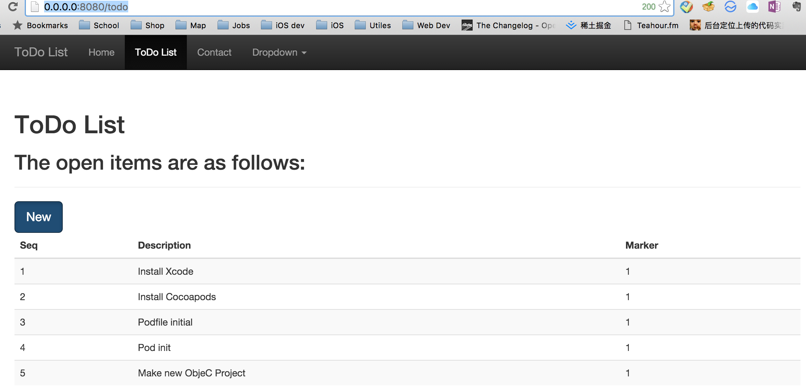

http://changcode.pythonanywhere.com/todo

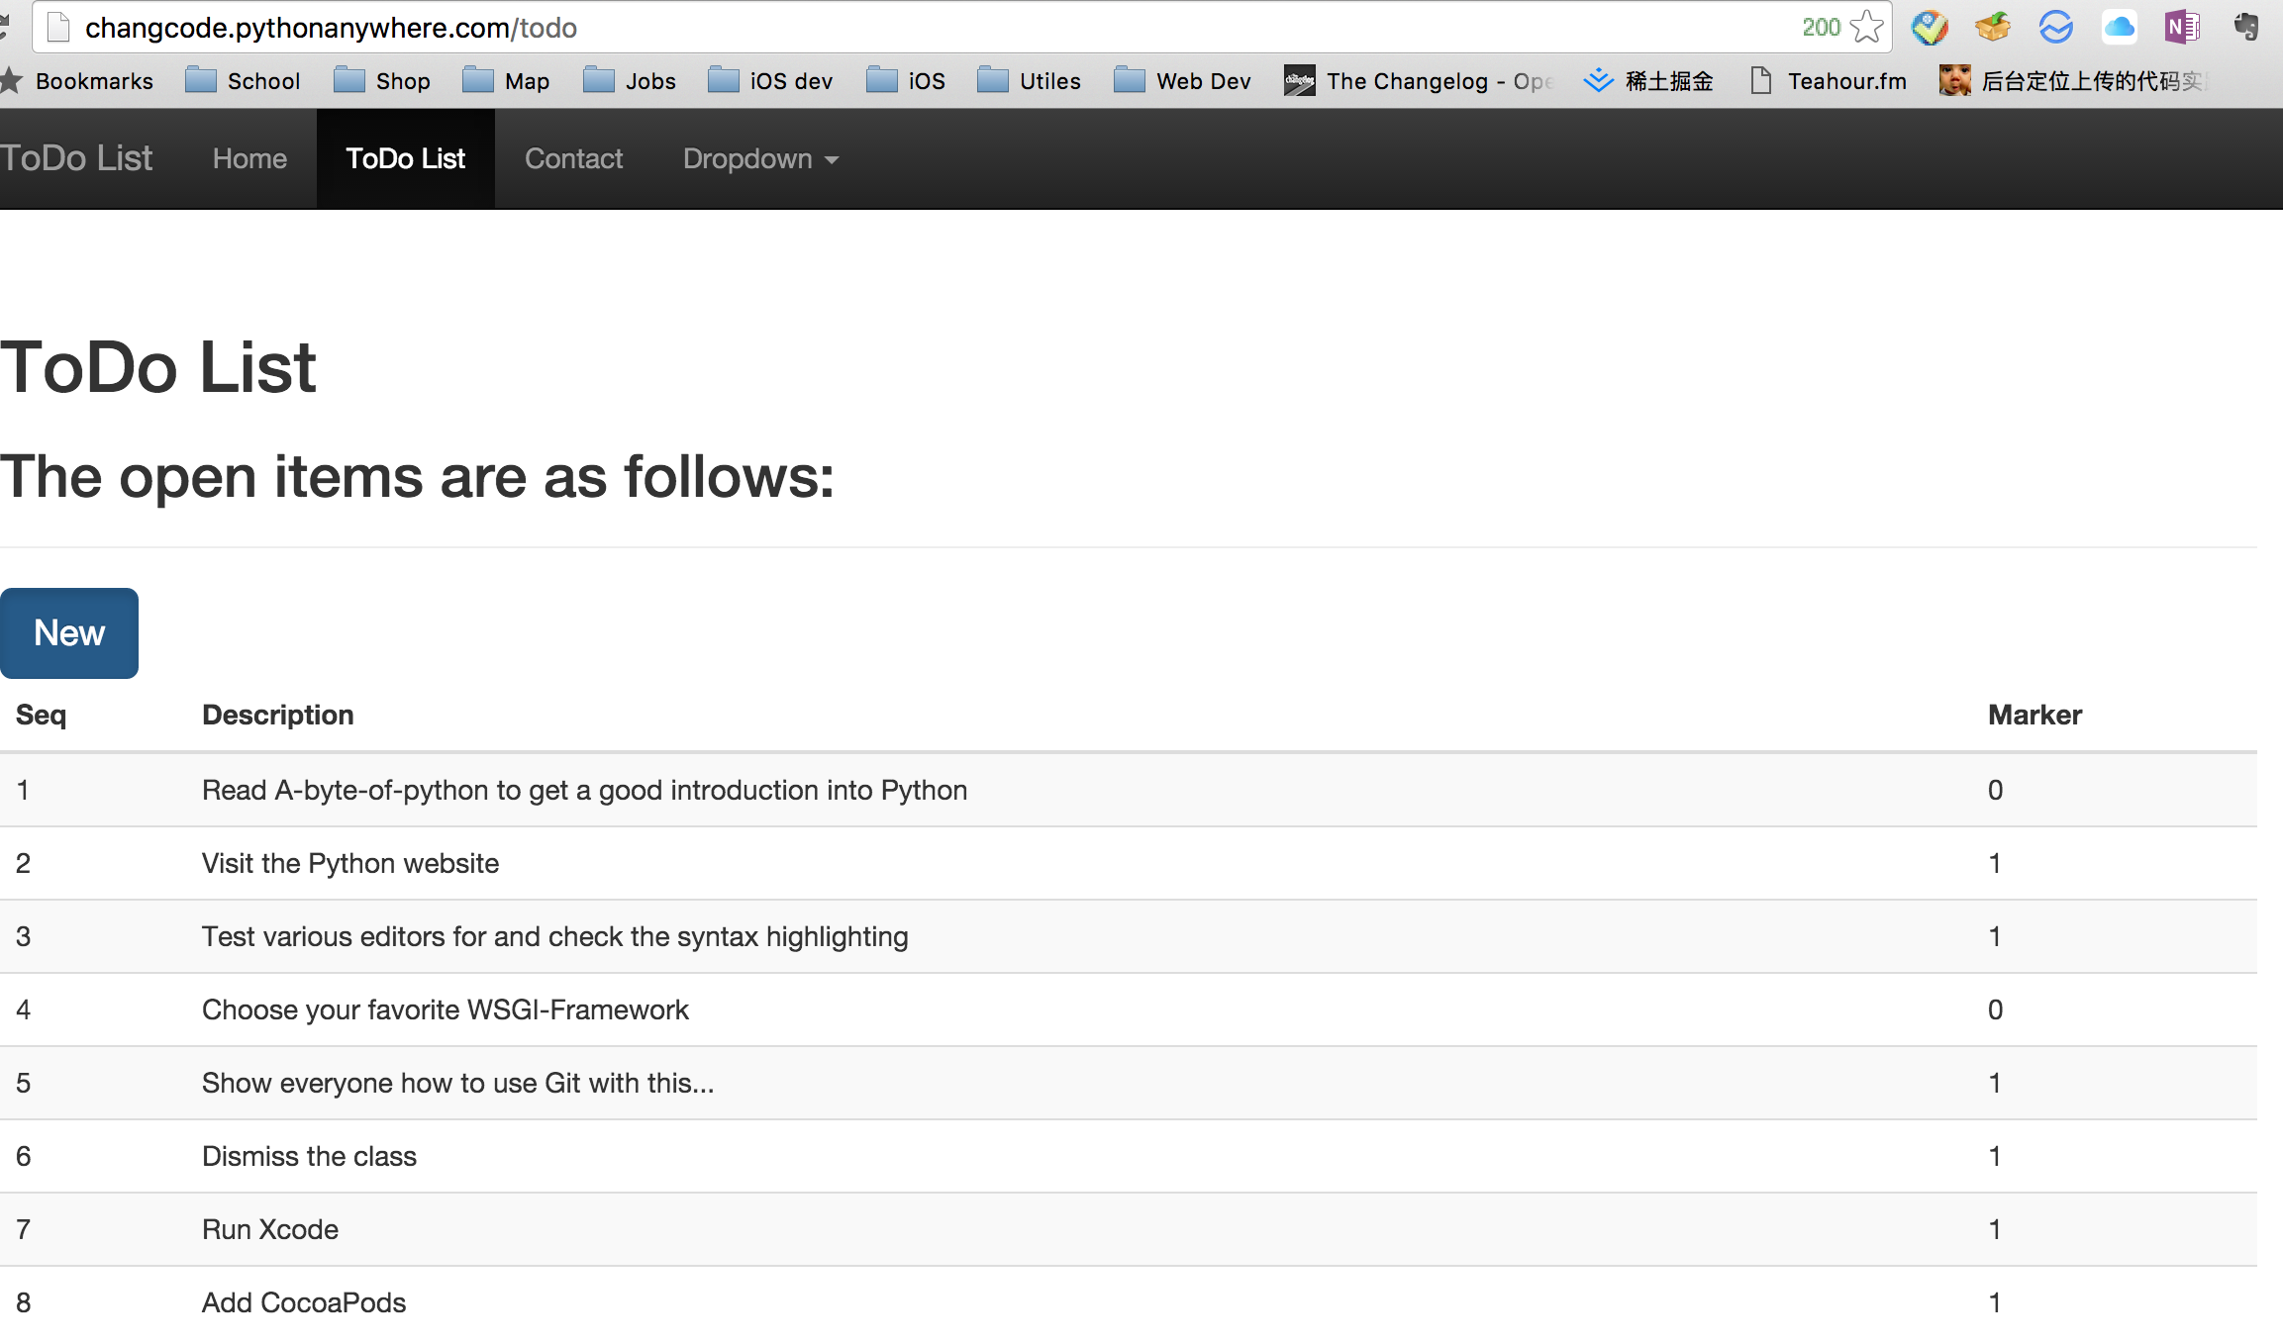

http://0.0.0.0:8080/new

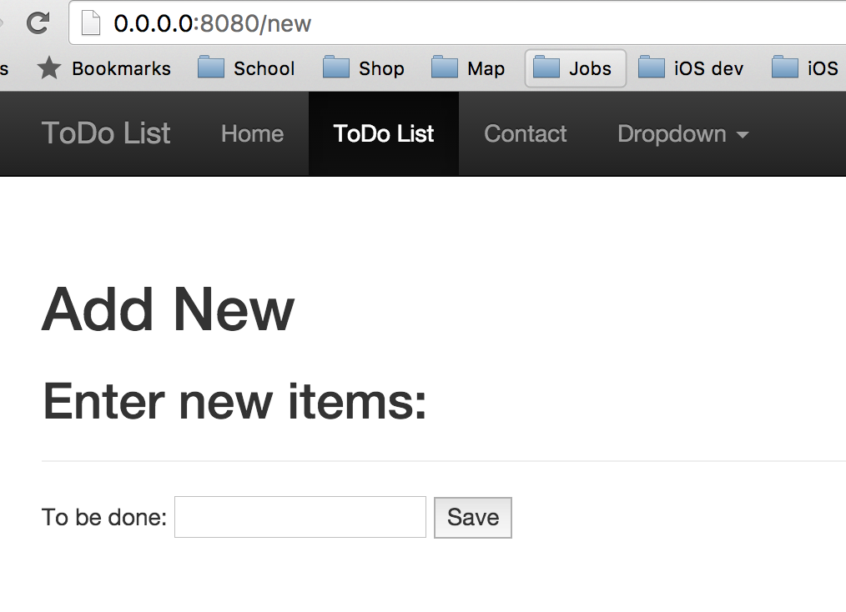

http://changcode.pythonanywhere.com/new

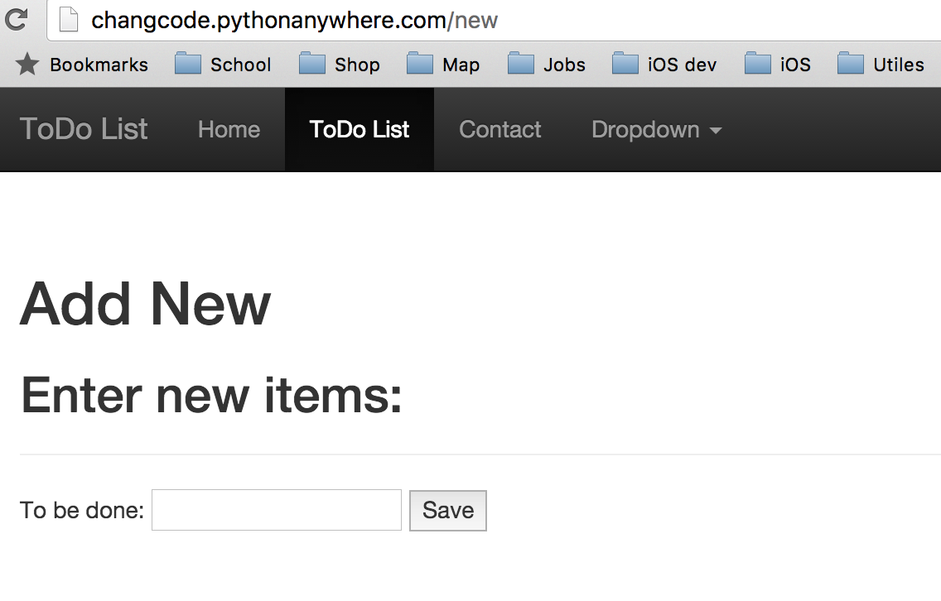

Code:

